**2CS701 Compiler Construction**

**Date:** 06/09/2022

**Roll No. and Name:** 19BCE250 DHVANI SHAH

**PRACTICAL 10:**  Code optimization technique – Minimum registers.

**Code:**

from collections import deque

def minimumColors(N, E, U, V):

    adj = [[] for i in range(N)]

    count = [0]*N

    colors = [1]*(N)

    for i in range(N):

        adj[V[i] - 1].append(U[i] - 1)

        count[U[i] - 1] += 1

        Q = deque()

    for i in range(N):

        if (count[i] == 0):

            Q.append(i)

    while len(Q) > 0:

        u = Q.popleft()

        for x in adj[u]:

            count[x] -= 1

            if (count[x] == 0):

                Q.append(x)

            if (colors[x] <= colors[u]):

                colors[x] = 1 + colors[u]

    minColor = -1

    for i in range(N):

        minColor = max(minColor, colors[i])

    print(minColor)

N = 5

E = 6

U = [1, 1, 2, 2, 3, 4]

V = [2, 4, 3, 5, 4, 5]

minimumColors(N, E, U, V)

Input -

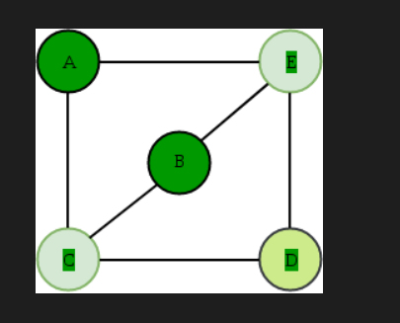

Output -

